Chapter 11, Solution 65.

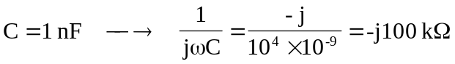

At the noninverting terminal,
